COMMON COURSE ASSIGNMENT FORMAT

- Assignment Information

Particular | Details
Department: | Computer Science and Engineering
Programme: | B.E./B.Tech. Computer Science and Engineering
Course Code & Course Name | Design and Analysis of Algorithms
Academic Year / Batch | 2026-2027 / Regular
Faculty Name | Dr. F. Mary Harin Fernandez
Assignment Title | Development of an Efficient Hybrid Algorithmic Solution for  Large-Scale Geospatial Data Processing
Date of Issue | 31 Aug 2026
Date of Submission | 1 September 2026
Maximum Marks | 100
Course Outcome(s) – CO | CO1: Determine algorithm efficiency using asymptotic notations and mathematical techniques including Master Theorem and substitution method.  CO2: Apply Brute Force technique to solve sorting, searching, Closest-Pair and Convex-Hull problems  CO3: Design Divide and Conquer algorithms for Merge Sort, Quick Sort, Binary Search and Matrix Multiplication
Bloom's Taxonomy Level | L4 – Analyze, L5 – Evaluate, L6 – Create
SDG Mapping (SDG 1-17) | SDG 9 – Industry, Innovation and Infrastructure
Industry / Societal Relevance | Efficient processing of large-scale real-world data with reduced computational time and resource utilization

1. Overview & Choice of Algorithmic Solution

Algorithms Evaluated
- Brute-Force Closest Pair: Evaluates all $\text{n}\left(\text{n}\text{−1}\right)\text{/2}$ possible point pairs exhaustively to find the pair with the minimum Euclidean distance.
- Divide-and-Conquer Closest Pair: Recursively splits the point set about the median x-coordinate, solves the subproblems for left and right halves, and checks a central dividing strip of width $\text{2}\text{δ}$.
- Adaptive Hybrid Closest Pair (Selected Solution): Integrates Divide-and-Conquer and Brute-Force by recursively partitioning the dataset until the subproblem size reaches an experimentally determined threshold (${\text{S}}_{\text{0}}$). Below this threshold, it dynamically switches to the Brute-Force approach.

Justification: Why the Adaptive Hybrid Approach Was Chosen
While Brute-Force is simple and Divide-and-Conquer provides optimal asymptotic bounds, neither represents the most efficient practical implementation on real-world geospatial data:
- Limitation of Standalone Brute-Force: As dataset size grows ($\text{n}\text{=}{\text{10}}^{\text{3}}\text{,}{\text{10}}^{\text{4}}\text{,}{\text{10}}^{\text{5}}$), its $\text{O}\left({\text{n}}^{\text{2}}\right)$ time complexity creates severe execution bottlenecks, making it computationally infeasible for large-scale infrastructure planning.
- Limitation of Standalone Divide-and-Conquer: Although its asymptotic time complexity is $\text{Θ}\left(\text{n}\text{log}{\text{n}}\right)$, recursive partitioning introduces substantial non-computational overhead. For very small subproblems ($\text{n}\text{≤15}$ or $\text{30}$), setting up recursion stack frames, making function calls, computing medians, and creating sub-arrays takes significantly more execution time than simply running a quick $\text{O}\left({\text{n}}^{\text{2}}\right)$ nested loop.
- Superiority of the Adaptive Hybrid Solution: The hybrid algorithm combines the macro-scalability of Divide-and-Conquer with the micro-efficiency of Brute-Force. By cutting off recursion early at threshold ${\text{S}}_{\text{0}}$, it eliminates high call-stack and array-slicing overhead for small input sizes while preserving the optimal $\text{O}\left(\text{n}\text{log}{\text{n}}\right)$ asymptotic theoretical growth for large datasets.

2. Problem Understanding and Formulation

Problem Context & Real-World Infrastructure Planning
Modern geospatial infrastructure systems—such as telecommunication networks, weather monitoring setups, and air traffic control systems—rely heavily on precise coordinate processing. In high-density facility mapping, identifying the closest pair of locations is critical for detecting redundant infrastructure, avoiding signal or physical interference between neighboring stations, and optimizing coverage across regions.

Input & Output Definitions
- Input: A dataset $\text{P}\text{=}\left\{{\text{p}}_{\text{1}}\text{,}{\text{p}}_{\text{2}}\text{,…,}{\text{p}}_{\text{n}}\right\}$ containing $\text{n}$ 2D spatial coordinate pairs, where each point ${\text{p}}_{\text{i}}\text{=}\left({\text{x}}_{\text{i}}\text{,}{\text{y}}_{\text{i}}\right)$ represents a facility's geographical position.
- Output: The pair of points $\left({\text{p}}_{\text{i}}\text{,}{\text{p}}_{\text{j}}\right)$ where $\text{i}\text{≠}\text{j}$ that minimizes the Euclidean distance $\text{d}\left({\text{p}}_{\text{i}}\text{,}{\text{p}}_{\text{j}}\right)$, alongside the calculated minimum distance value $\text{δ}$.

Distance Metric Formulation
The spatial distance between any two facilities ${\text{p}}_{\text{i}}\text{=}\left({\text{x}}_{\text{i}}\text{,}{\text{y}}_{\text{i}}\right)$ and ${\text{p}}_{\text{j}}\text{=}\left({\text{x}}_{\text{j}}\text{,}{\text{y}}_{\text{j}}\right)$ is computed using the standard 2D Euclidean distance formula:
$$\text{d}\left({\text{p}}_{\text{i}}\text{,}{\text{p}}_{\text{j}}\right)\text{=}\sqrt{{\left({\text{x}}_{\text{i}}\text{−}{\text{x}}_{\text{j}}\right)}^{\text{2}}\text{+}{\left({\text{y}}_{\text{i}}\text{−}{\text{y}}_{\text{j}}\right)}^{\text{2}}}$$

Computational Challenges & Scalability Constraints
- $\text{O}\left({\text{n}}^{\text{2}}\right)$ Complexity Bottleneck: The naive brute-force approach compares every unique point pair. For a dataset with $\text{n}$ records, the total number of distance operations is:
$$\frac{\text{n}\left(\text{n}\text{−1}\right)}{\text{2}}$$
As $\text{n}$ grows to ${\text{10}}^{\text{5}}$ or ${\text{10}}^{\text{6}}$ coordinates, ${\text{n}}^{\text{2}}$ grows quadratically (e.g., ${\text{10}}^{\text{10}}$ to ${\text{10}}^{\text{12}}$ comparisons), leading to execution bottlenecks, high CPU utilization, and latency issues.
- Memory & Processing Limits: Performing global sorting and maintaining nested pairwise loops on dynamic or large datasets exhausts memory and leads to excessive processor thrashing.

Key Assumptions & Constraints
- Coordinates are mapped to a 2D Cartesian plane using planar projections.
- Dataset records are free of duplicate coordinate entries that yield a trivial zero distance.
- Computational evaluations are conducted in identical runtime environments across all three algorithmic variants to ensure consistency.

3. Theoretical Complexity Analysis

1. Brute-Force Closest Pair
- Mechanism: Checks all $\text{n}\left(\text{n}\text{−1}\right)\text{/2}$ possible combinations.
- Time Complexity Analysis:
  - Worst Case: $\text{Θ}\left({\text{n}}^{\text{2}}\right)$
  - Best Case: $\text{Ω}\left({\text{n}}^{\text{2}}\right)$ (always checks all pairs regardless of point layout)
  - Average Case: $\text{O}\left({\text{n}}^{\text{2}}\right)$
- Space Complexity: $\text{O}\left(\text{1}\right)$ auxiliary space (excluding input array storage).

2. Divide-and-Conquer Closest Pair
- Mechanism: Sorts points by x-coordinate, splits the dataset into left and right halves around median line ${\text{x}}_{\text{mid}}$, recursively finds minimum distances ${\text{δ}}_{\text{L}}$ and ${\text{δ}}_{\text{R}}$, sets $\text{δ}\text{=}\text{min}\left({\text{δ}}_{\text{L}}\text{,}{\text{δ}}_{\text{R}}\right)$, and checks a central strip of width $\text{2}\text{δ}$ sorted by y-coordinate.
- Time Complexity Analysis:
  - Presorting takes $\text{O}\left(\text{n}\text{log}{\text{n}}\right)$ time.
  - Strip processing checks at most 7–8 points for each point inside the strip, bounded by $\text{O}\left(\text{n}\right)$.
  - Total recurrence: $\text{T}\left(\text{n}\right)\text{=2}\text{T}\left(\text{n}\text{/2}\right)\text{+}\text{O}\left(\text{n}\right)$.
  - Overall Time Complexity: $\text{Θ}\left(\text{n}\text{log}{\text{n}}\right)$.
- Space Complexity: $\text{O}\left(\text{n}\right)$ space required for storing sorted coordinate arrays and strip structures.

3. Adaptive Hybrid Closest Pair
- Mechanism: Recursively splits subproblems using Divide-and-Conquer until subproblem size $\text{n}\text{≤}{\text{S}}_{\text{0}}$ (where ${\text{S}}_{\text{0}}$ is the threshold size), at which point it switches to Brute-Force.
- Time Complexity Analysis:
  - Asymptotic behavior remains $\text{O}\left(\text{n}\text{log}{\text{n}}\right)$ because ${\text{S}}_{\text{0}}$ is a fixed constant.
  - Reduces recursive overhead, stack frame creations, and array copying overheads for small inputs.
- Space Complexity: $\text{O}\left(\text{n}\right)$ for dynamic strip handling and recursion stack.

4. Step-by-Step Master Theorem Recurrence Proof
To analyze the Divide-and-Conquer recurrence relation:
$$\text{T}\left(\text{n}\right)\text{=2}\text{T}\left(\frac{\text{n}}{\text{2}}\right)\text{+}\text{f}\left(\text{n}\right)\text{, }\text{where} \text{f}\left(\text{n}\right)\text{=}\text{O}\left(\text{n}\right)$$

Step 1: Identify Master Theorem Parameters
The general Master Theorem recurrence equation is:
$$\text{T}\left(\text{n}\right)\text{=}\text{aT}\left(\frac{\text{n}}{\text{b}}\right)\text{+}\text{f}\left(\text{n}\right)$$
From our divide-and-conquer function:
- $\text{a}\text{=2}$ (number of subproblems generated per recursive call)
- $\text{b}\text{=2}$ (factor by which input size is divided)
- $\text{f}\left(\text{n}\right)\text{=}\text{O}\left(\text{n}\right)$ (work done outside recursion for dividing and merging strip points)

Step 2: Compute ${\text{n}}^{{\text{log}}_{\text{b}}{\text{a}}}$
$${\text{n}}^{{\text{log}}_{\text{b}}{\text{a}}}\text{=}{\text{n}}^{{\text{log}}_{\text{2}}{\text{2}}}\text{=}{\text{n}}^{\text{1}}\text{=}\text{n}$$

Step 3: Compare $\text{f}\left(\text{n}\right)$ with ${\text{n}}^{{\text{log}}_{\text{b}}{\text{a}}}$
- $\text{f}\left(\text{n}\right)\text{=}\text{Θ}\left(\text{n}\right)$
- ${\text{n}}^{{\text{log}}_{\text{b}}{\text{a}}}\text{=}\text{Θ}\left(\text{n}\right)$
Since $\text{f}\left(\text{n}\right)\text{=}\text{Θ}\left({\text{n}}^{{\text{log}}_{\text{b}}{\text{a}}}\right)$, Case 2 of the Master Theorem applies.

Step 4: Apply Case 2 Formula
Under Case 2 of the Master Theorem:
$$\text{T}\left(\text{n}\right)\text{=}\text{Θ}\left({\text{n}}^{{\text{log}}_{\text{b}}{\text{a}}}\text{⋅}\text{log}{\text{n}}\right)$$
Substituting ${\text{n}}^{{\text{log}}_{\text{2}}{\text{2}}}\text{=}\text{n}$:
$$\text{T}\left(\text{n}\right)\text{=}\text{Θ}\left(\text{n}\text{log}{\text{n}}\right)$$
Conclusion: The theoretical time complexity of the Divide-and-Conquer core is strictly $\text{Θ}\left(\text{n}\text{log}{\text{n}}\right)$.

5. Hybrid Switching Strategy & Architectural Flowchart

Mathematical Justification of Hybrid Switching
While Divide-and-Conquer exhibits asymptotic superiority ($\text{Θ}\left(\text{n}\text{log}{\text{n}}\right)$ vs. $\text{Θ}\left({\text{n}}^{\text{2}}\right)$), the constant factors hidden within the Big-O notation differ significantly:
- Divide-and-Conquer Running Time: ${\text{C}}_{\text{D}\text{\&}\text{C}}\text{⋅}\text{n}{\text{log}}_{\text{2}}{\text{n}}\text{+}\text{Recursion} \text{Overhead}$
- Brute-Force Running Time: ${\text{C}}_{\text{BF}}\text{⋅}\frac{\text{n}\left(\text{n}\text{−1}\right)}{\text{2}}$
For small subproblems ($\text{n}\text{<}{\text{S}}_{\text{0}}$), ${\text{C}}_{\text{D}\text{\&}\text{C}}\text{>}{\text{C}}_{\text{BF}}$ due to system stack operations. By introducing a dynamic cutoff point ${\text{S}}_{\text{0}}$, the algorithm bypasses recursion overhead for small subsets without increasing total asymptotic complexity.
Architecture Diagram:
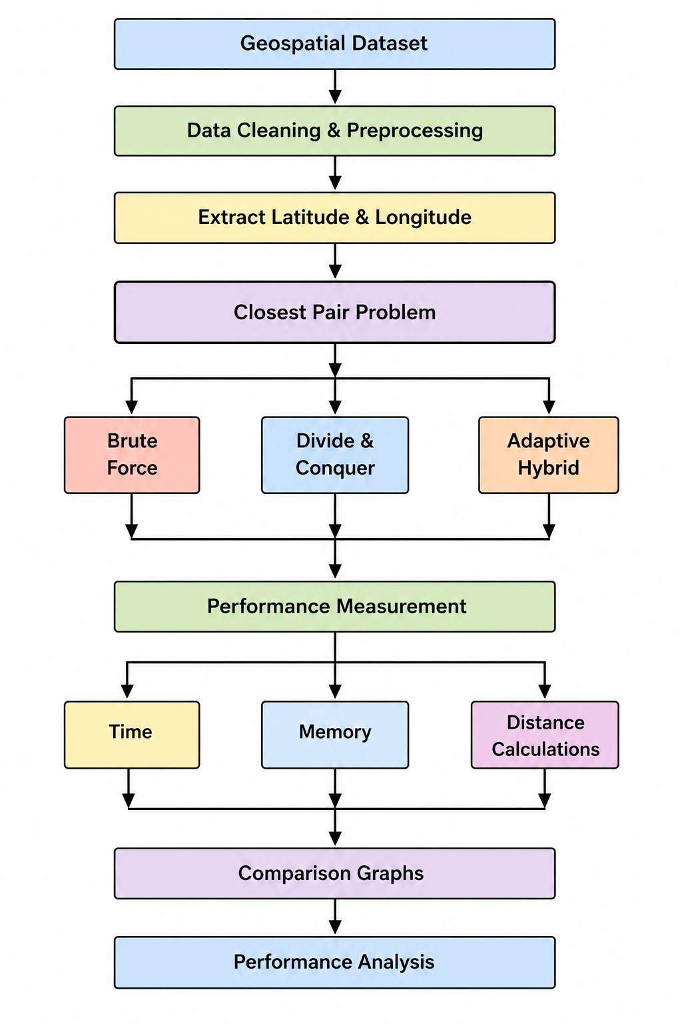
Comparison Graphs:

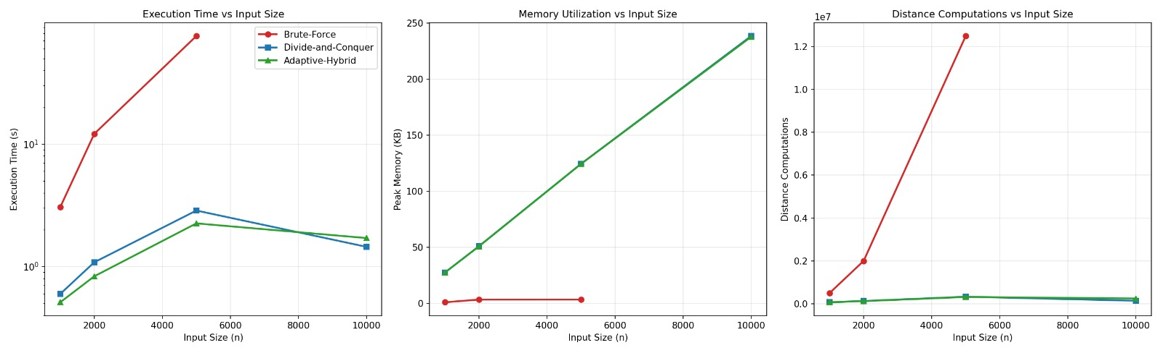




- Threshold & benchmark performance analysis :
Final Performance Comparison :
Input Size | Brute Force Time (s) | D&C Time (s) | Hybrid Time (s) | BF Distances | D&C Distances | Hybrid Distances
100 | 0.041965 | 0.002921 | 0.002973 | 4,950 | 110 | 122
500 | 0.945402 | 0.020931 | 0.019579 | 124,750 | 532 | 837
1,000 | 4.183207 | 0.046656 | 0.047578 | 499,500 | 1,081 | 1,698
2,000 | 16.972906 | 0.099826 | 0.093704 | 1,999,000 | 2,175 | 3,405
5,000 | 104.588459 | 0.292670 | 0.331480 | 12,497,500 | 6,123 | 10,663

Execution Time Analysis :
Brute Force execution time increased rapidly from 0.041965 s at 100 points to 104.588459 s at 5,000 points. D&C required only 0.292670 s, while Hybrid required 0.331480 s at 5,000 points. Thus, D&C and Hybrid scale much better than Brute Force.

Threshold Optimization:
Eight threshold values from 5 to 50 were tested. The lowest average execution time was 0.260426 s at threshold 5. Therefore, 5 was selected as the optimal Hybrid threshold.

Threshold Analysis:
A threshold of 5 resulted in only 10,663 distance calculations, compared with 46,424 at threshold 20 and 95,172 at threshold 40. Larger thresholds increase Brute-Force processing, resulting in more distance calculations and higher execution time.
Theoretical vs Experimental Comparison:
Algorithm | Theoretical Time | Experimental Performance
Brute Force | O(n2)O(n^2) | Increased rapidly with input size
Divide & Conquer | O(nlog⁡n)O(n\log n) | Very good scalability
Hybrid | O(nlog⁡n)O(n\log n) | Very good scalability with threshold 5

Engineering Decision:
Brute Force is suitable for small datasets but does not scale well. D&C provided the fastest performance for the tested dataset, while Hybrid with threshold 5 provided an efficient adaptive solution by combining D&C with Brute Force. Therefore, D&C is the best-performing algorithm in the experiment, while Hybrid is the preferred adaptive approach.

B. Assessment Rubric

Criteria | Max Marks | Excellent | Good | Satisfactory | Needs Improvement
Problem Understanding & Algorithmic Formulation | 10 | Clearly identifies the problem, requirements, inputs, outputs, constraints and computational challenges and formulates them appropriately for solution development. | Problem and major requirements are correctly formulated with minor gaps. | Basic formulation is provided, but requirements or constraints are partially identified. | Problem is poorly understood or inadequately formulated.
Algorithmic Solution Design | 15 | Designs a clear, logical and feasible solution strategy with appropriate algorithmic techniques, pseudocode/flowchart and well-justified design decisions. | Appropriate solution design with minor gaps in logic, representation or justification. | Basic solution design is presented but lacks completeness or clear justification. | Solution design is inappropriate, incomplete or unclear.
Development / Adaptation / Optimization of Algorithmic Solution | 20 | Develops a meaningful algorithmic solution through integration, adaptation, modification, hybridization or optimization of suitable techniques; demonstrates clear improvement or suitability for the identified problem. | Develops an appropriate solution with meaningful adaptation or improvement, with minor limitations. | Solution demonstrates limited adaptation or development beyond standard implementation. | Merely reproduces an existing algorithm with little or no meaningful development or adaptation.
Implementation & Modern Tool Usage | 15 | Developed solution is correctly and efficiently implemented using appropriate programming/computational tools and handles relevant input conditions reliably. | Implementation is functional with minor logical or efficiency issues. | Core implementation works but contains limitations or incomplete functionality. | Implementation is incomplete, unreliable or non-functional.
Efficiency, Testing & Validation | 15 | Performs appropriate complexity evaluation and systematic testing using suitable data/input sizes; validates correctness, efficiency and scalability with clear evidence. | Complexity evaluation and testing are mostly appropriate with minor gaps. | Basic testing and efficiency evaluation are provided but lack sufficient validation. | Testing, complexity evaluation or validation is inadequate or substantially incorrect.
Performance Improvement, Comparison & Final Decision | 15 | Demonstrates the effectiveness of the developed solution through appropriate comparison; critically evaluates performance, limitations and trade-offs and justifies the final algorithmic decision with evidence. | Good performance comparison and justification with minor limitations. | Basic comparison is provided, but improvement or final justification lacks depth. | Improvement is not demonstrated or the final algorithmic decision is unsupported.
Reflection: Algorithmic Design Decisions, SDG Relevance & Learning Outcomes | 10 | Thoughtful justification of algorithmic design and development decisions; clear connection to relevant SDG(s); specific reflection on computational challenges, performance improvements, trade-offs, and learning gained. | Appropriate justification of algorithmic decisions; SDG relevance, challenges, improvements, and learning are discussed but lack depth. | Reflection is present but generic; limited justification of algorithmic decisions, improvements, SDG relevance, or learning outcomes. | No genuine reflection is provided, or the reflection lacks meaningful connection to algorithm development, SDG relevance, challenges, or learning outcomes.
Total | 100

- CO–PO–Assessment Mapping

Assessment Component | CO | PO(s) | Bloom's Level | Marks
Problem Understanding & Algorithmic Formulation | CO1 | PO1, PO2 | L4 | 10
Algorithmic Solution Design | CO2, CO3 | PO2, PO3 | L4, L6 | 15
Development / Adaptation / Optimization of Algorithmic Solution | CO2, CO3 | PO2, PO3 | L5, L6 | 20
Implementation & Modern Tool Usage | CO2, CO3 | PO3, PO5 | L3, L6 | 15
Efficiency, Testing & Validation | CO1, CO2, CO3 | PO2, PO4 | L4, L5 | 15
Performance Improvement, Comparison & Final Decision | CO1, CO2, CO3 | PO2, PO4 | L4, L5 | 15
Reflection: Algorithmic Design Decisions, SDG Relevance & Learning Outcomes | CO1, CO2, CO3 | PO7, PO10, PO12 | L4, L5 | 10
- Faculty Evaluation & Continuous Improvement CO Attainment

Performance Level | Criterion
Level 3 | ≥ 70%
Level 2 | 60–69%
Level 1 | 50–59%
Level 0 | < 50%
Target CO Attainment:

Actual CO Attainment:

Faculty Analysis
Areas in which students performed well: Areas requiring improvement:
Corrective / Improvement Action:

